Lab 06

Exercise

1.

i) Binomial distribution

ii)

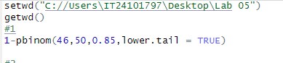

2.

i) Number of calls per hour

ii) poisson distribution

iii)

